

**Street Manager**

Ancillary Information User Guide

**Version 1.0**

**March 2023**

**Adding ancillary**

**information**



Open an existing permit application 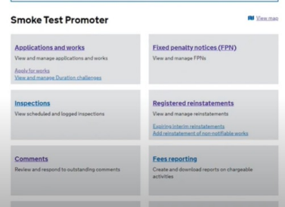

within the application and works list

page.



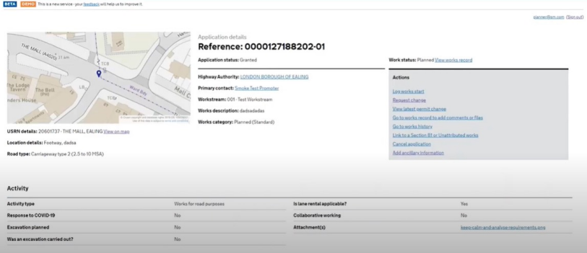

Select ‘Add ancillary

information’. This option is

available on both planned

works and works that are in

progress.



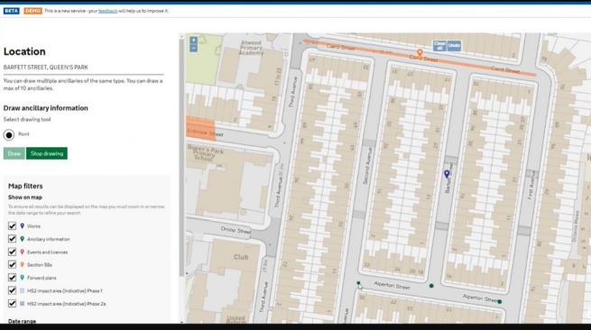

Select ‘draw’ and use this tool to indicate your

ancillary information. In the example on the left, we have placed three dots to indicate the position of temporary traffic lights. When you have finished, select ‘stop drawing’.



Street Manager will automatically pick up

associated USRNs. Select the relevant

USRNs to link by clicking the check boxes.

When you have finished, select ‘Link

USRNs’



The next screen will give you an opportunity to select your ancillary type and add a description of the ancillary information you are adding.





On the next screen you will have the opportunity to review the ancillary

information details. You can make changes by selecting the ‘change’ button.

The ancillary reference will 

now be displayed. If you 

select view application 

details you will now see

the ancillary information 

section at the bottom of 

the application page.





Select ‘View on map’ to

see the ancillary

information in map view.



**Removing**

**ancillary**

**information**







To remove ancillary information select ‘View ancillary information details’. On the next screen select ‘Remove ancillary information’



Use the text box to enter the reasons why the ancillary information is no longer required, then click ‘Remove ancillary 

information’.

When you return to the

permit page, you will now

see that the ancillary

information status has

changed to ‘removed’.

